25ESCS01- INTRODUCTION TO PROBLEM SOLVING CONTINIOUS ASSESSMENT – 3 & 4
EXAM DATE: 19/11/25 (WEDNESDAY)
SET: 2 Admission Number: JUUGI202511830
Name: ASHUTOSH KUMAR JHA

Q1: if..else
Code:
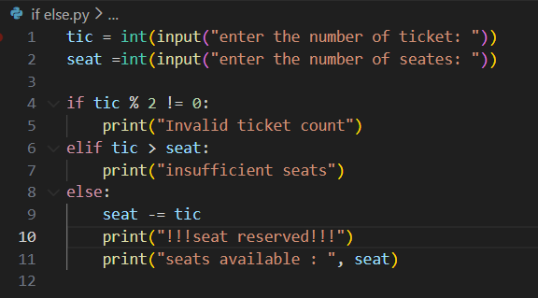
Output:
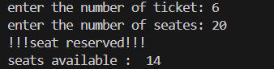

Q2: for
Code:
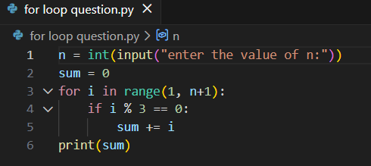

Output:
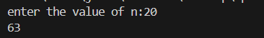

Q1: while
Code:
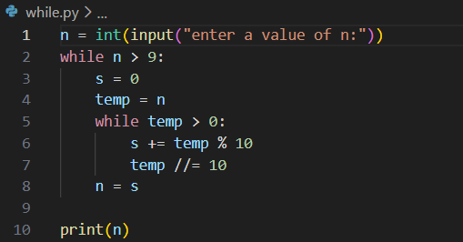

Output:
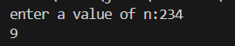

Q1: functions
Code:
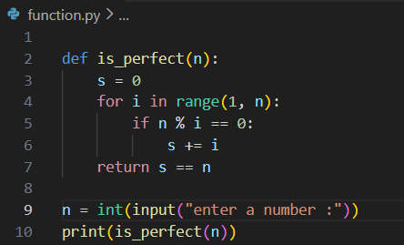

Output:
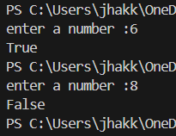

Q1: list
Code:
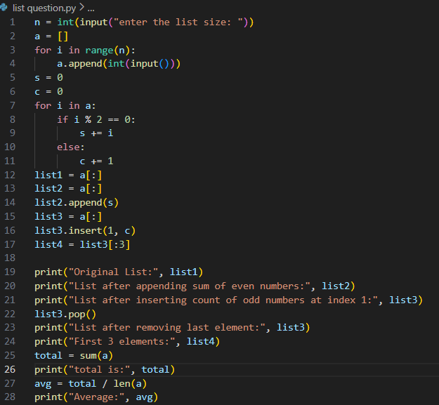

Output:
